**USER MANUAL**

1. User has to register an account with the following credentials:

* E-Mail
* Password
* Zip Code
* User ID

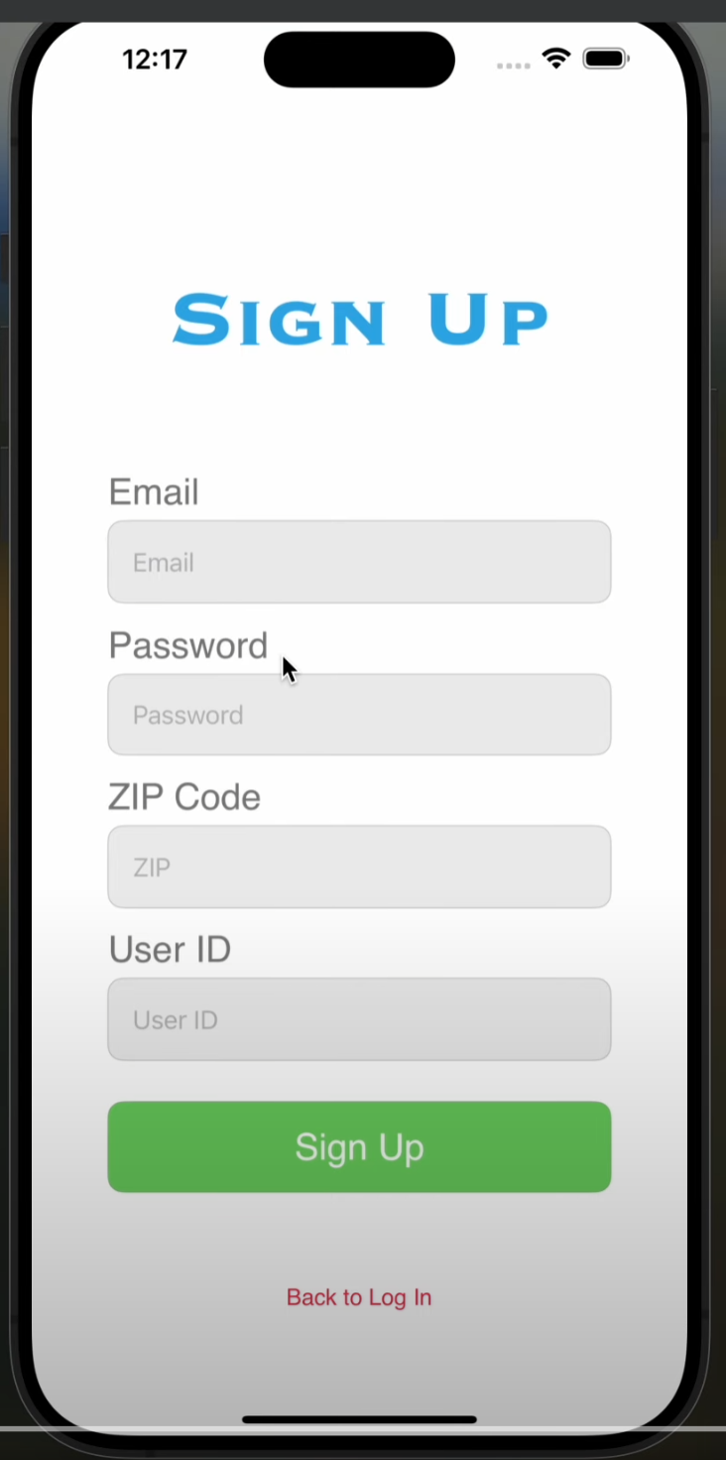

1. User has to log in with new registered account, or a previous registered account saved on the database, must have the following credentials:

* E-Mail
* Password

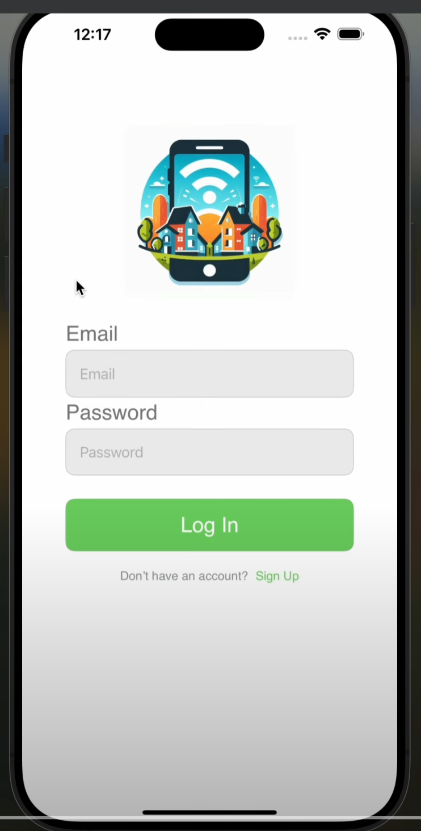

1. User is greeted at the home page that displays the users registered events in chronological order

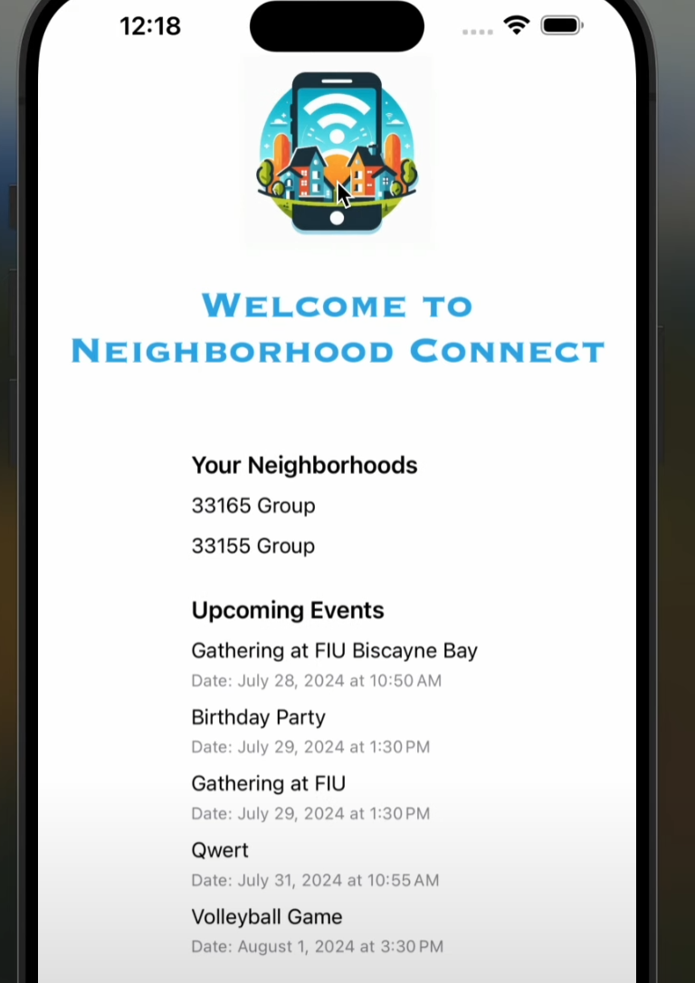

1. User has four button options to choose from at the bottom of their screen:

* Create neighborhood group
* Search for neighborhood groups
* Users group and event management
* Settings

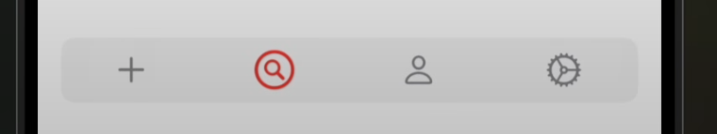

1. When the user chooses the plus sign (“Create neighborhood group”) option, they are met with five input options, which they fill out and tap“Create Group” button to create the group with the inputted information:

* Group Name
* Zip Code
* Age Range

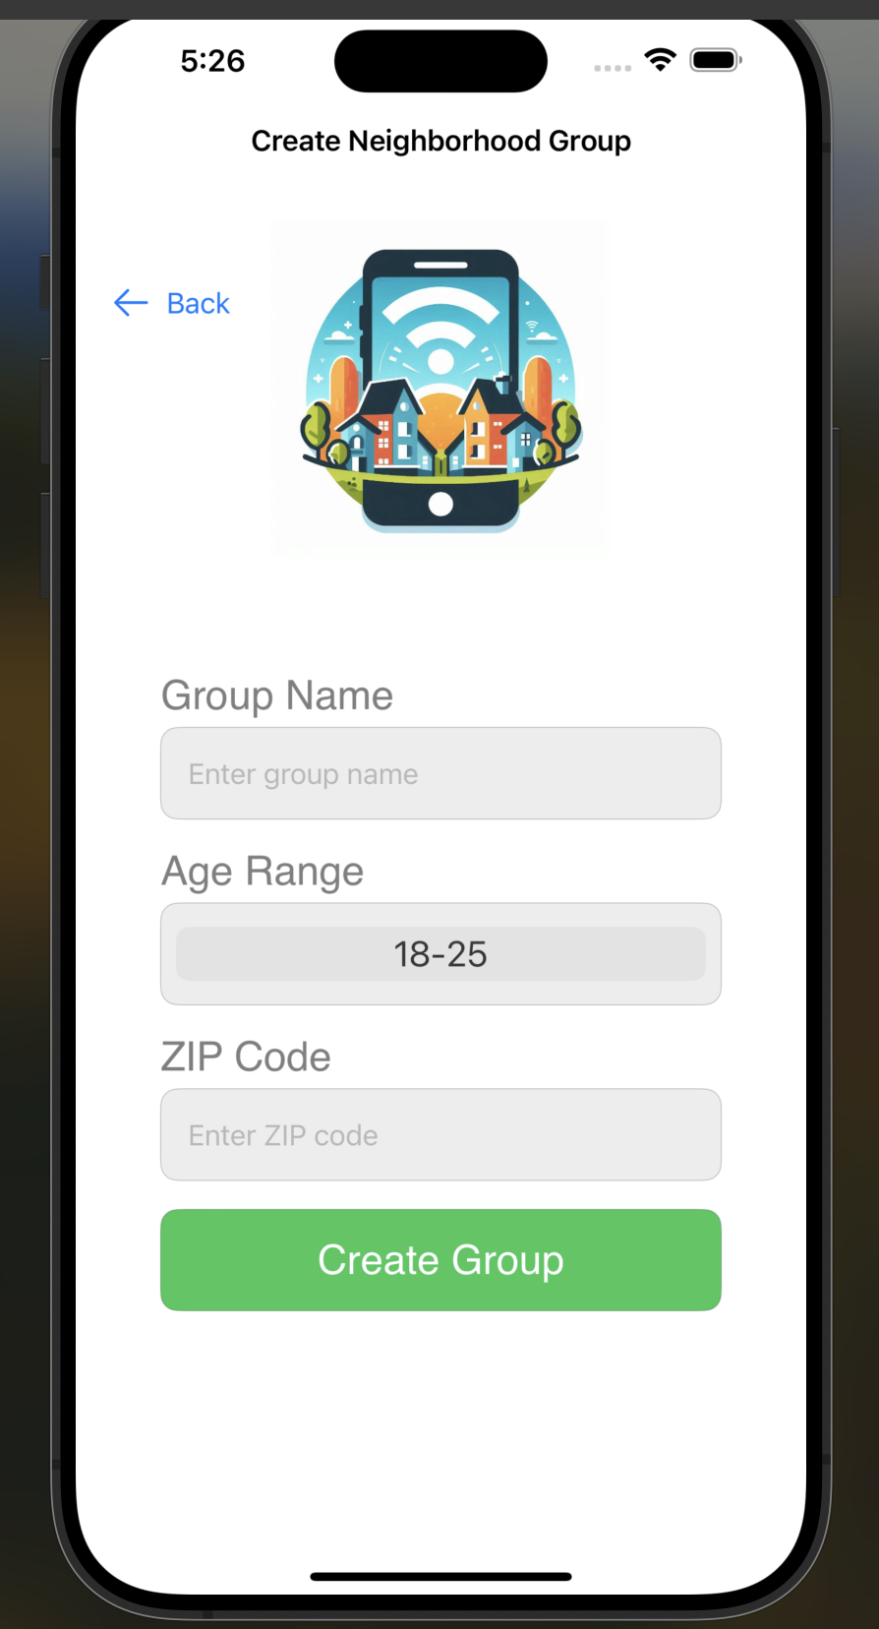

1. When the user chooses the magnifying glass (“Search for neighborhood groups”) option, they are met with two input text options which they fill out and tap “Search”:

* Zip Code
* Age

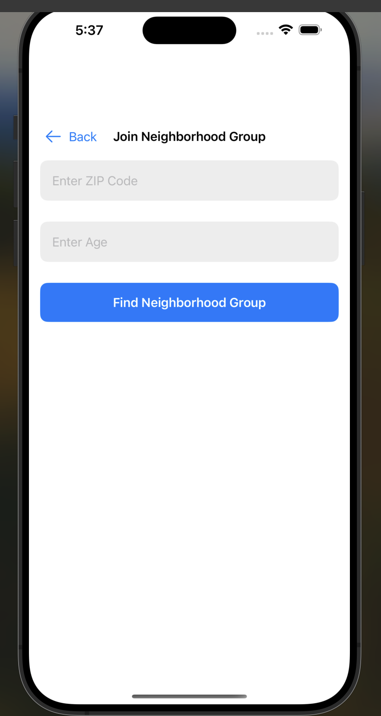

1. After entering the criteria, groups that match the criteria will show up and the user is able to join the groups.

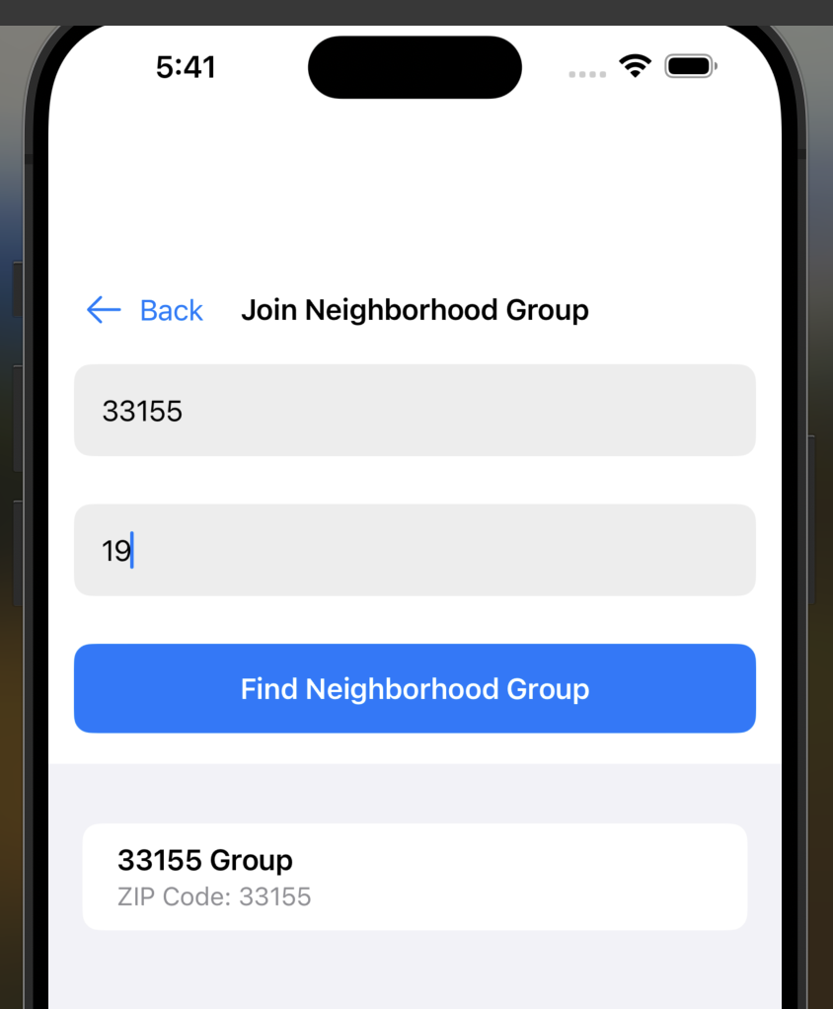

1. When the user chooses the person icon “Groups Created or Joined View” option, they are met with two sections:

* Created Neighborhood Groups
* Joined Neighborhood Groups

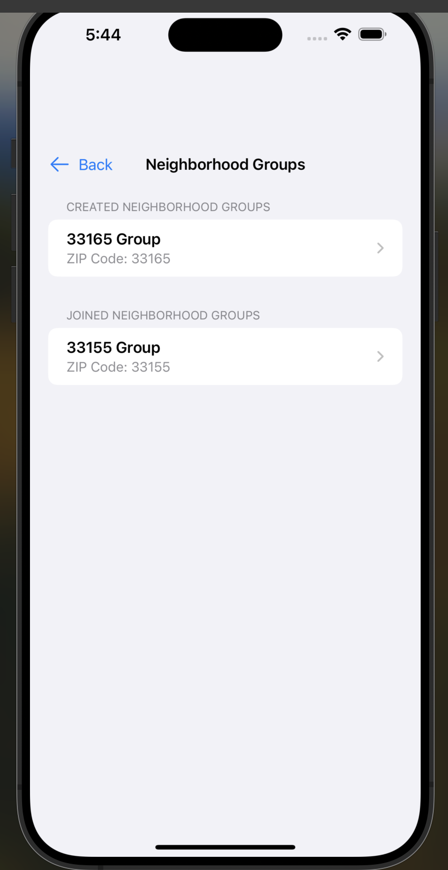

1. When the user chooses a neighborhood group they are redirected to the “GroupChatOptionView” which shows these options:

* Chat
* Create Event
* Sign Up for Event
* View Events

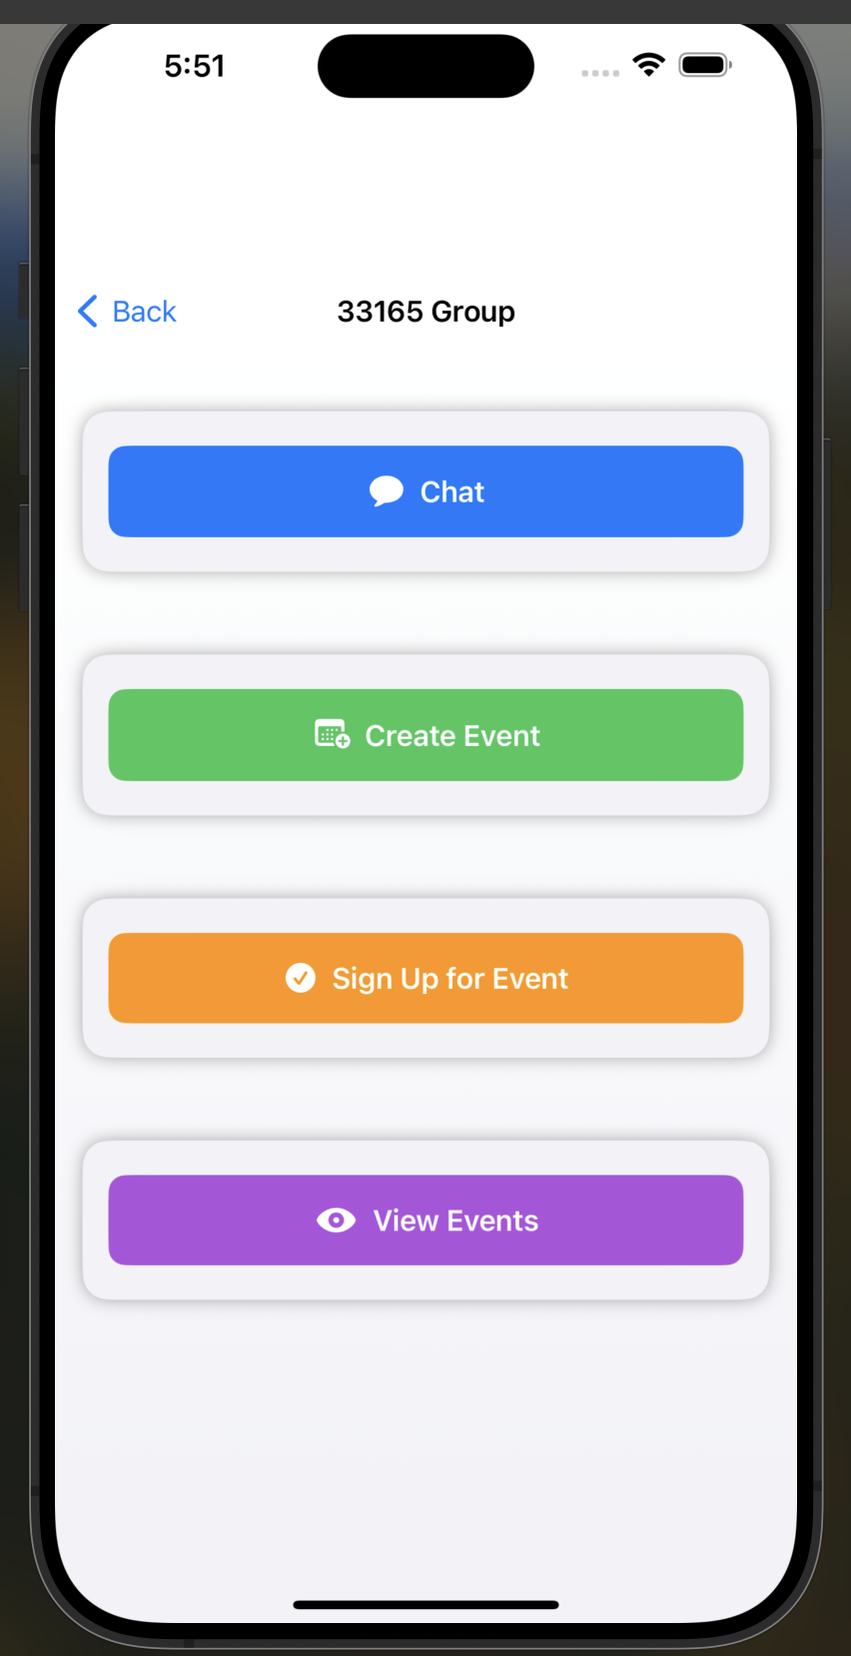

1. When a user chooses the “Chat” option the user is able to chat with other neighborhood group members. This page contains a text field and a send message button.

* Message Text Field
* Send Message Button

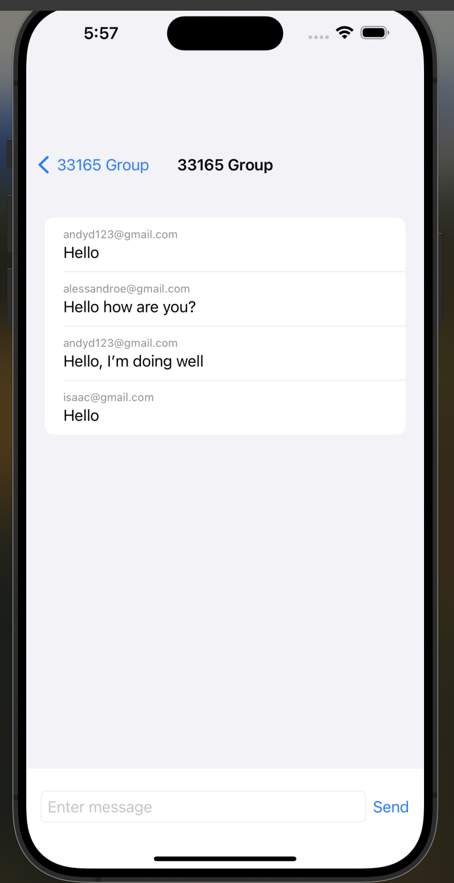

1. When the user chooses the “Create Event” option, they are met with four inputs, which they fill out and tap the “Create Event” button to create the event for the group:

* Event Name
* Event Type
* Event Description
* Event Location/Address
* Event Date and Time

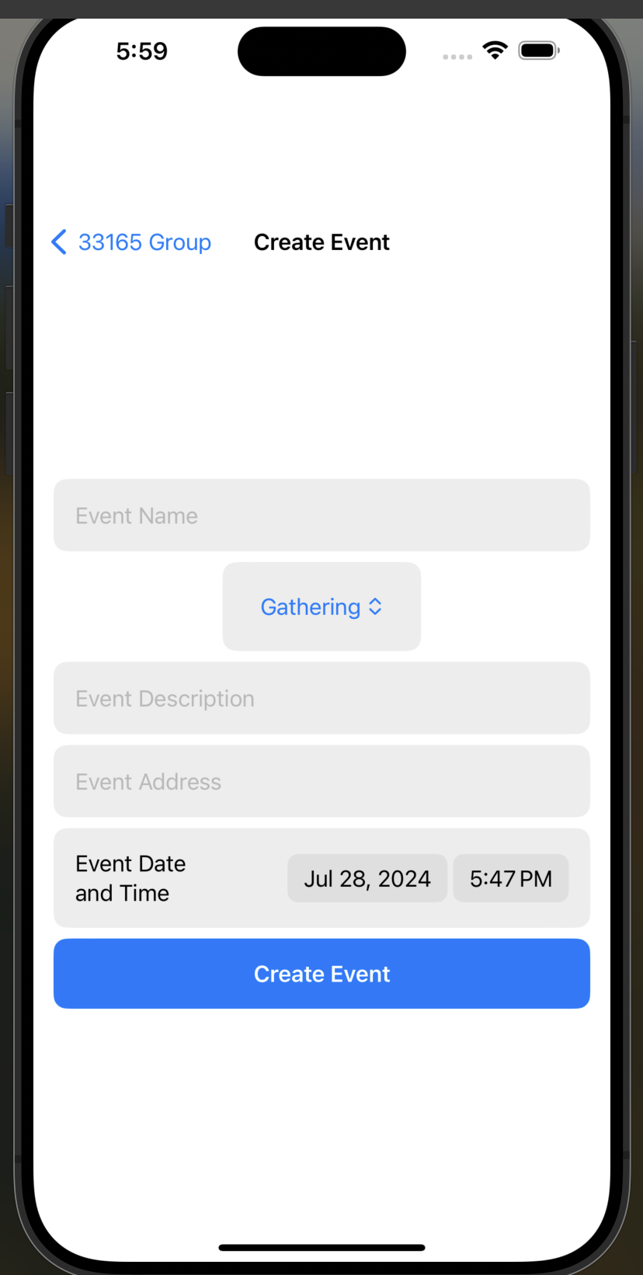

1. When the user chooses the “Sign Up for Event” option, they are met with a list of events for that neighborhood group, and they are able to subscribe to any event that is listed, and also view the event details.

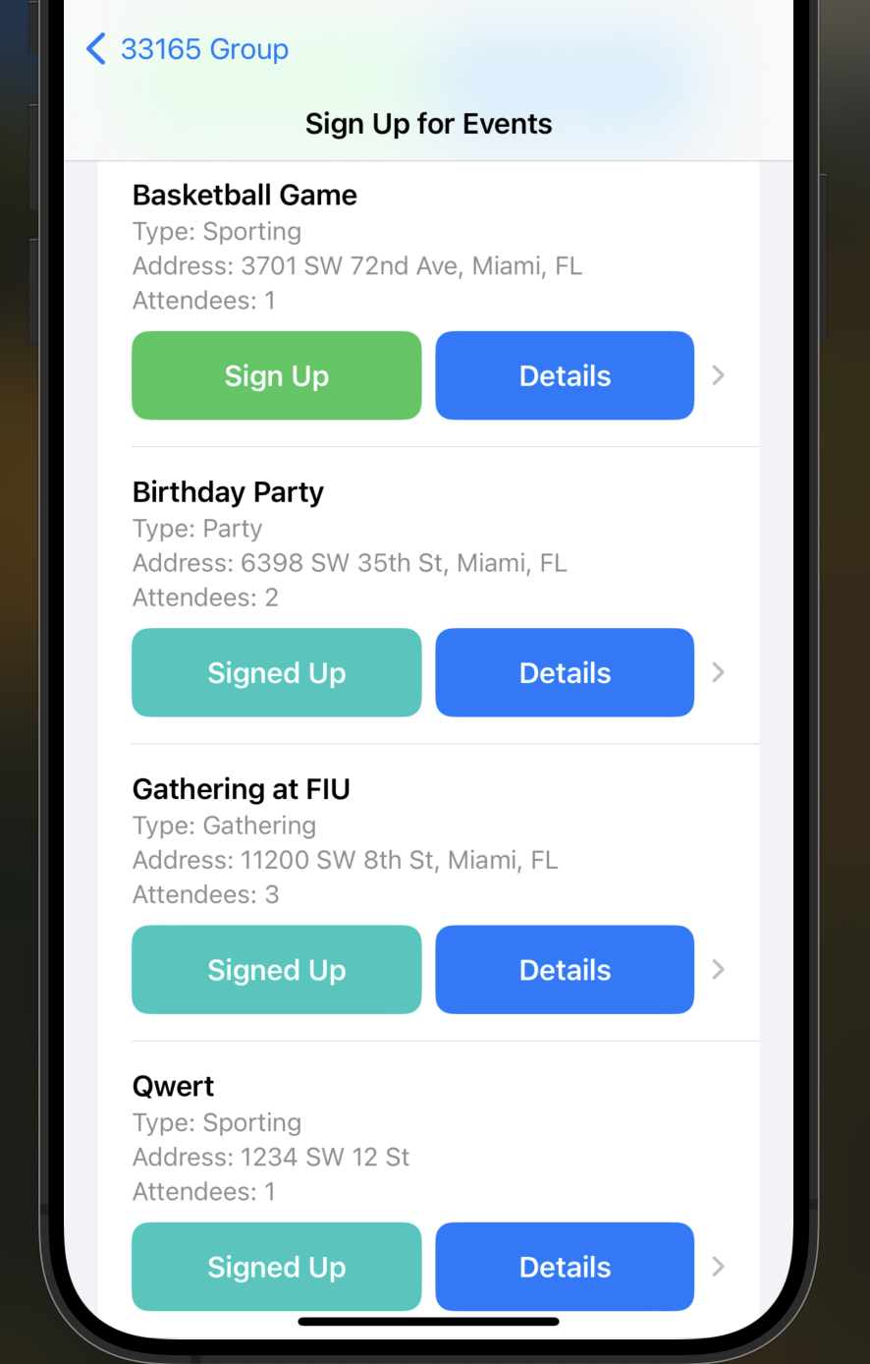

1. When the user taps on the “View Events” option, they are met with a list of events that the user has signed up for, similar to the Home page, but this time with a “Details” button. The user can also unsubscribe from any events they are signed up for.

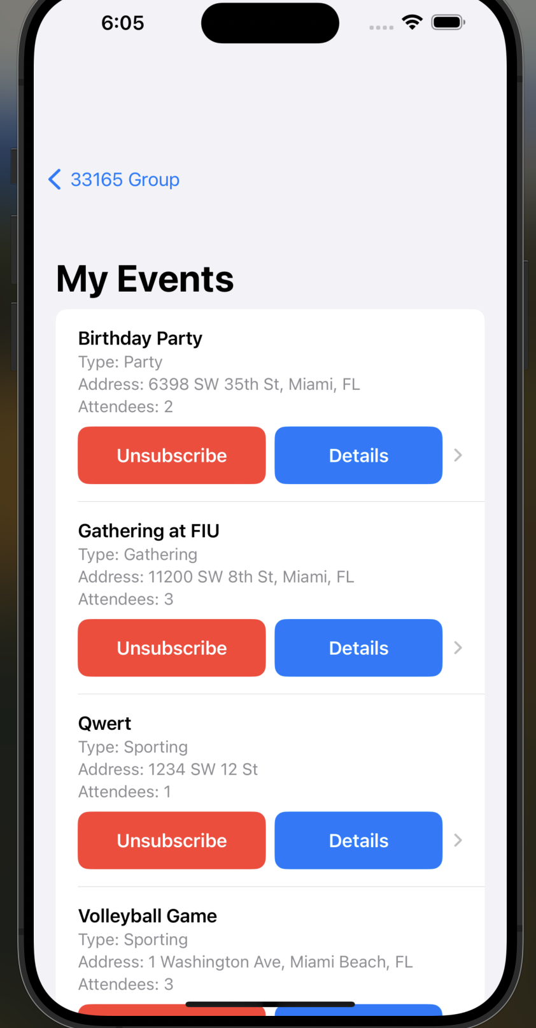

1. If the user taps on the “Details” button that is assigned to an event, they are met with a page that showcases the event’s information:

* Event Name,
* Event Type
* Event Description
* Event Location
* Visual map of where the event is located

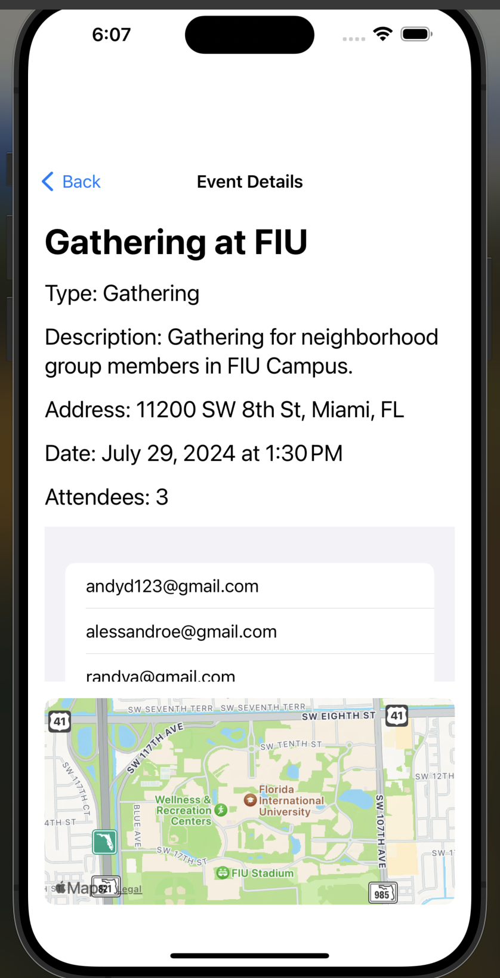

1. When the user chooses the gear icon (“Settings”) option, they are met with a page that displays their User ID and Email, along with a button to log out of their account.

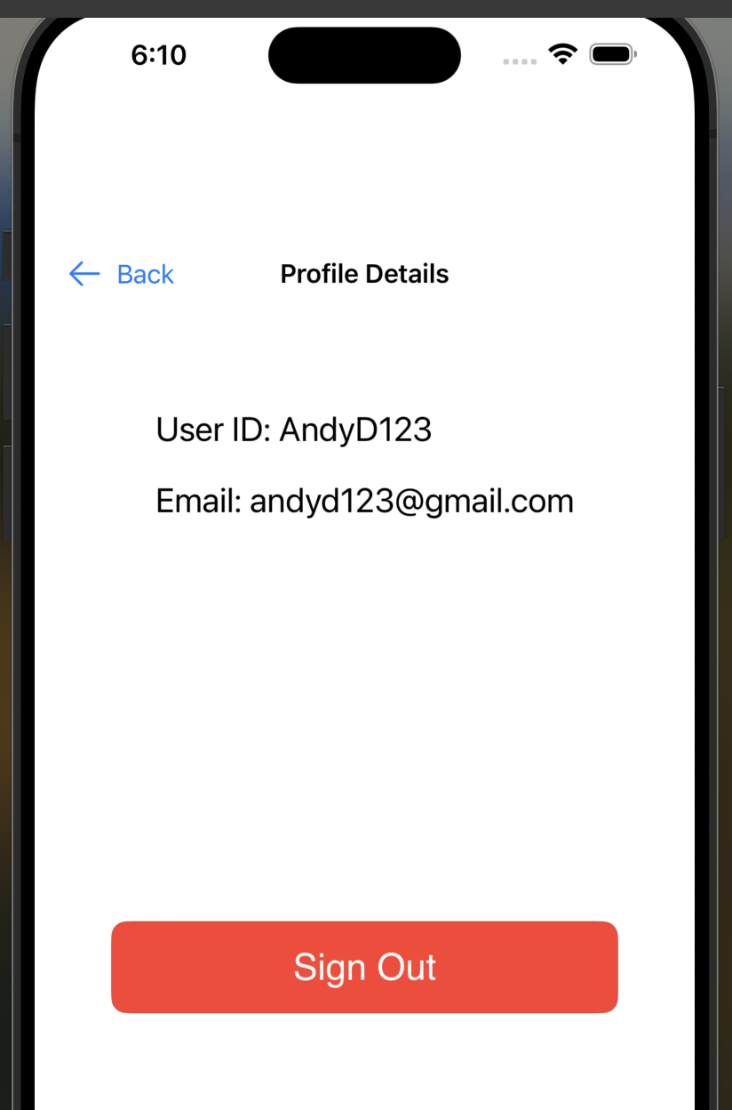

1. When the user taps the “Log out” button, they are sent to the Login screen.